Very high cycle fatigue properties of high strength steel

Ichiro Suzuki¹, Takashi Nakamura^{1,}*, Tatsuo Sakai² and Hiroyuki Oguma³

¹ Division of Mechanical and Space Engineering, Hokkaido University, Japan
² Department of Mechanical Engineering, Ritsumeikan University, Japan
³ Research Center for Structural Materials, National Institute for Materials Science, Japan

* Corresponding author: nakamut@eng.hokudai.ac.jp

ABSTRACT:
This document is a template and contains all style and formatting required for the abstract. The paper should be A4 size and the margin are: top/bottom 25.4 mm; left/right 19.05 mm. The major font sizes and styles used in this template are: 1) Title: Arial 14 pt bold; 2) Authors: Arial 12 pt; 3) Affiliation: Arial 10 pt italic; 4) Corresponding author: Arial 10 pt; 5) Main text: Arial 11 pt, justified. The abstract should not exceed 200 words in length. You can add one or two figures within one page if necessary. After finalizing the abstract, please access to the VHCF8 website and submit it as a PDF file (.pdf) less than or equal to 3MB.

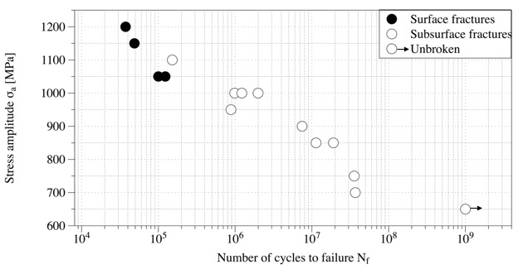

Fig. 1 S-N plots of the material used.

